**XAMPP for Website Local Hosting**

Fuguo Xue

**XAMPP** is a free and open-source cross-platform web server solution stack package developed by Apache Friends. For my re-designed website, XAMPP allows it to have a local database.

## A. Pre-requisite

To get access to XAMPP Control Panel, a computer with Windows 2008, 2012, Vista, 7, 8 or higher is required (Important: XP or 2003 not supported). This file will go through the XAMPP installation process on Windows 10. If you’re using Linux or Mac OS X, then the steps listed below for the installation process may differ.

## B. Install XAMPP on Windows 10

1. First, download XAMPP from the website: <https://www.apachefriends.org/download.html>. I use XAMPP version 8.2.4 / PHP 8.2.4.
2. Double-click on the downloaded .exe file to start the installation. You may need to allow the program to temporarily deactivate antivirus software and User Account Control  (UAC) to finish the installation.
3. Under ‘Select Components’, select all the checkboxes. This is to make sure that we have a full local test server.

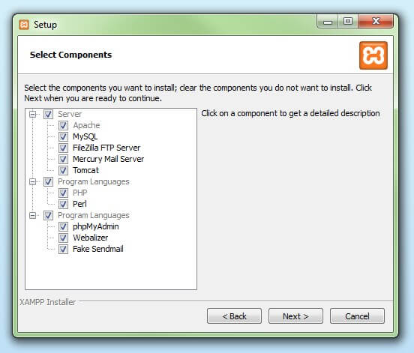

1. Follow the default location for XAMPP installation.

1. Click ‘Next’ and wait for the installation to finish.

## C. Set up XAMPP

1. Open the XAMPP Control Panel. On the panel, click the Apache ‘Config’ button and select ‘Apache (httpd.conf)’. It will open a text file.

1. Inside the text file, press ‘Ctrl’ + ‘F’ and search for the string ‘Listen 80’. Change it to ‘Listen 8000’. Save the file and close it.

1. Next, start the Apache, MySQL and Mercury module.

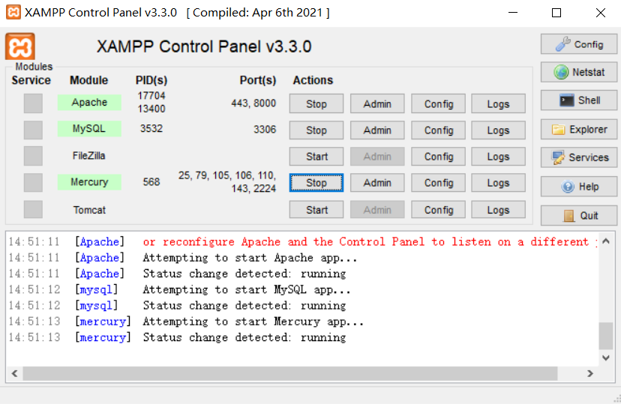

## D. Initialize the Database

1. Go to ‘C:\xampp\htdocs’, and create a folder named ‘PhDHub’. Inside ‘PhDHub’, create a folder named ‘website’.
2. Move all the website files to the location: ‘C:\xampp\htdocs\PhDHub\website’.
3. In Chrome, go to ‘http://localhost:8000/phpmyadmin/index.php’.
4. To initialize the database, click on ‘Import’ tab. You should see the interface below. Then, click on ‘Choose File’ and select the ‘leadership.sql’ file from ‘C:\xampp\htdocs\PhDHub\website’.

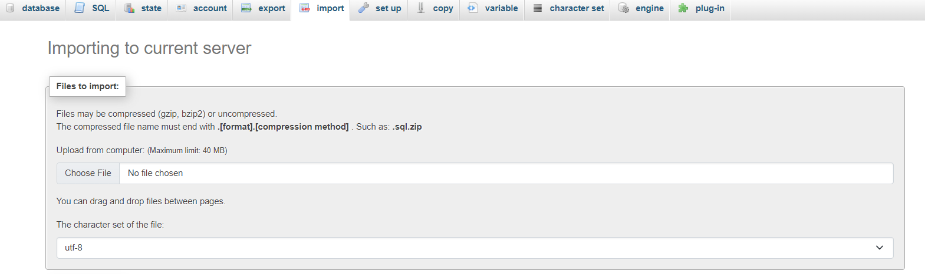

1. Next, scroll to the bottom and click the ‘Import’ button.

If the ‘leadership.sql’ file is imported successfully, you should see a tab named ‘leadership’ in the left side column, which contains a table called ‘workshops’. If click on ‘workshops’, you will see the initial 4 rows of data appeared on the right.

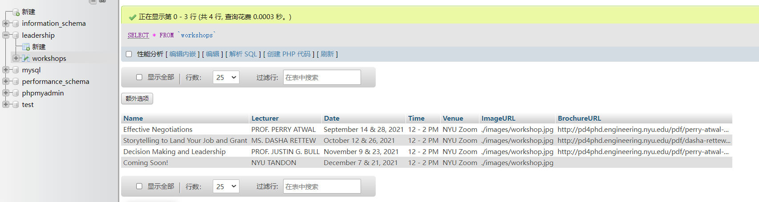

## E. View the Webpage with XAMPP

1. Before opening the webpage, make sure that ‘Apache’, ‘MySQL’, and ‘Mercury’ are all running.



1. In Chrome (or other search engines), go to ‘http://localhost:8000/PhDHub/’. You shall see a webpage listing all the files in your local ‘PhDHub’ folder. Click on the ‘website’ folder, and you will see the webpage I re-designed.

## F. Database management

It is easy to update the workshop information displayed on the webpage. You may learn how to update the database in the ‘leadership.sql’ file, where I have included comment lines to explain the updating process.